Date: 17/09/2024
Roll No. and Name: 24ITC087 Khush Pithva
Course Code and Name: 2CS101 Computer Programming
Practical No: 4(a)
AIM: Draw following patterns:
A  A B  A B C  A B C D | 1  0 1  1 0 1  0 1 0 1

Methodology followed:
#include <stdio.h>
int main() {
char ch;

for (int i = 1; i <= 4; i++) {
for (int j = 1; j <= i; j++) {
ch = 'A' + j - 1;
printf(" %c", ch);
}
printf("\n");
}

return 0;
}
Input/Output:
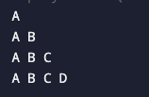
Practical : 4(a)(2)
#include<stdio.h>
int main()
{
int n;
for(int i=1;i<=4;i++){
for (int j = 1; j <= i; j++) {
if ((i + j) % 2 == 0) {
printf(" 1");
} else {
printf(" 0");
}
}
printf("\n");
}
}
Output :
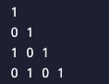

Theoretical principle used:
For the first time the “for” loop nested is used to print the following pattern.

Practical No:4(b)
AIM: To determine whether the entered number is prime.
Methodology followed:
#include <stdio.h>

int main()
{
int n,dv,temp=0;
printf("\n Enter any number : ");
scanf("%d",&n);
for(dv=2;dv<n;dv++)
{
if(n%dv==0)
{
temp=1;
break;
}
}
if(temp==0)
{
printf("\n Number is prime number ");
}
else
{
printf("\n number is not prime number ");
}
}

Input/Output:
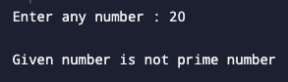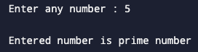
Theoretical principle used:
For loop is used to determine whether the number input by the user is a prime number or not.

Practical No: 4(c)
AIM: Enhance the number guessing game developed earlier.The Program should now display more appropriate messages(Greater,Smaller or Correct). It should allow a maximum of 5 attempts from stand still if the user cannot guess the numbers correctly,it should display“Sorry”.

Methodology followed:
#include <stdio.h>
#include <stdlib.h>
#include <time.h>

int main() {
int secret_number, guess;
int min = 1, max = 100;

srand(time(NULL));

secret_number = rand() % (max - min + 1) ;

printf("Welcome to the Number Guessing Game!\n");
printf("I have chosen a number between %d and %d.\n", min, max);

for(int i=0;i<=4;i++) {
printf("Enter your guess: ");
scanf("%d", &guess);

if (guess < secret_number) {
printf("Smaller \n");
} else if (guess > secret_number) {
printf("Greater \n");
}
else if(guess==secret_number)
{
printf("\nCorrect");
break;
}
}
if(guess!=secret_number)
printf("\n Sorry!!!");
}

Input/Output:
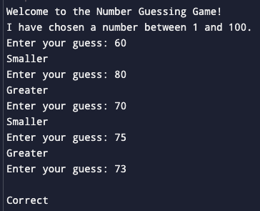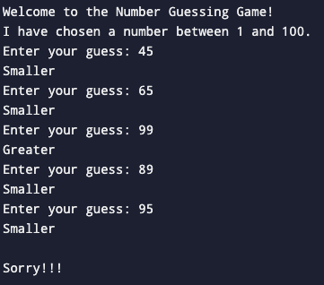

Theoretical principle used:
Using for loops now, the user has 5 attempts to guess the correct number. Loops and the function random is used simultaneously.

Conclusion:
I have learnt to apply loops in different situations with combination of the knowledge I gained earlier.

